Prerequisites:

* You should have minikube cluster running.
* Then you should have lens running so that you can view the pods and services.

Kong deployment using helms

* Files
* In certs file you have all the files related to certificates and using generate files you can create the certificates
* Helm will give you the templates to add the configuration. You donot have to install everything.
* Helm you should be installed in your system
* Then in helm you need to provide the values in the template.
* Helm new this is to create new file in helm
* Helm clean it will delete the configuration
* Helm upgrade it will update the changes what you have done
* 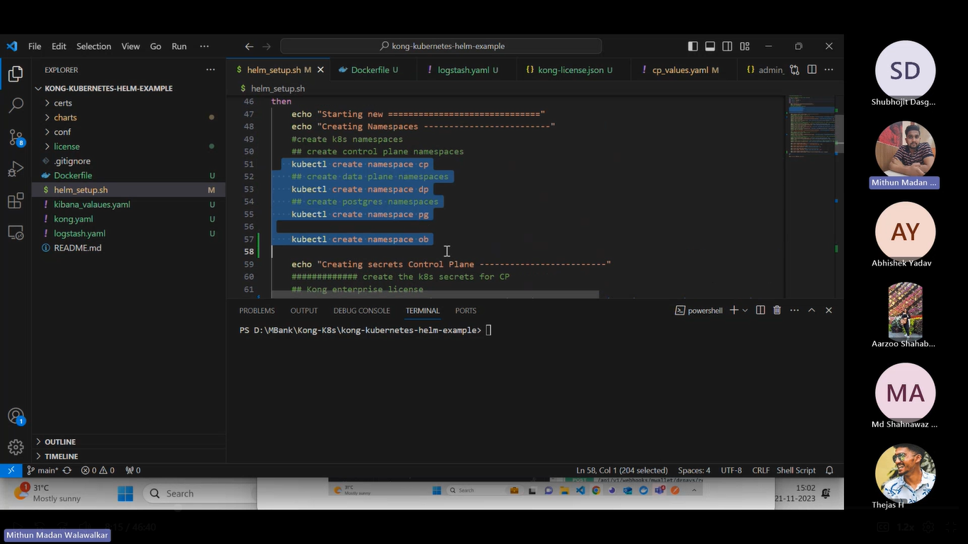
* These are the some commands
* There is a command in kubernates for creating secret it will store the secrets
* 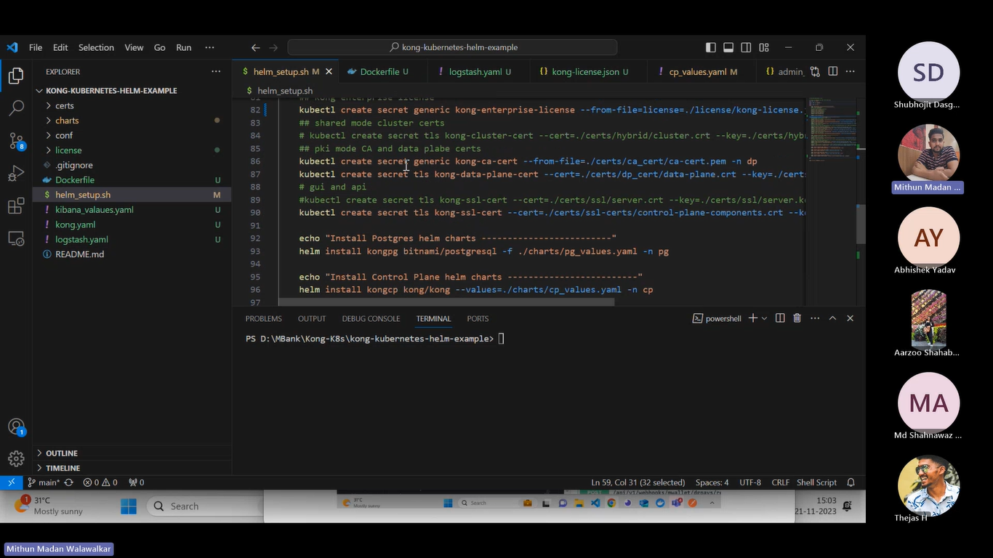
* In kubernates secret helps the to store the secret**. kubectl create secret .** this will helsp to store all your secrets.
* 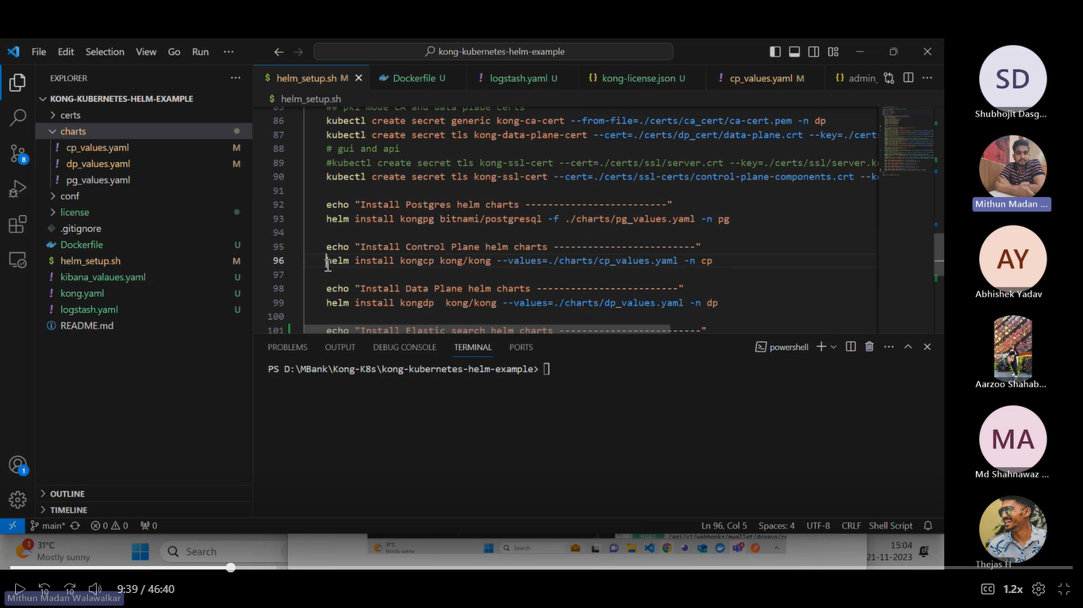
* Helm install kongpg this command helps ti install the helm and -f helps to go to that file and then that file reads all the configurations and then it will install.
* Helm install helps to install helm and store the installed configuration in kongpg which will be read from charts/pg folder and under the namespace pg
* So first we need add the repos to the helm then only we can install the particular image
* It is similar to your docker where first we need to pull a image then only we can use that image
* 
* This image we need to run first so that we can use the kong
* For postgress also below commands we need to run
* 
* This will install the psotgres using helm
* 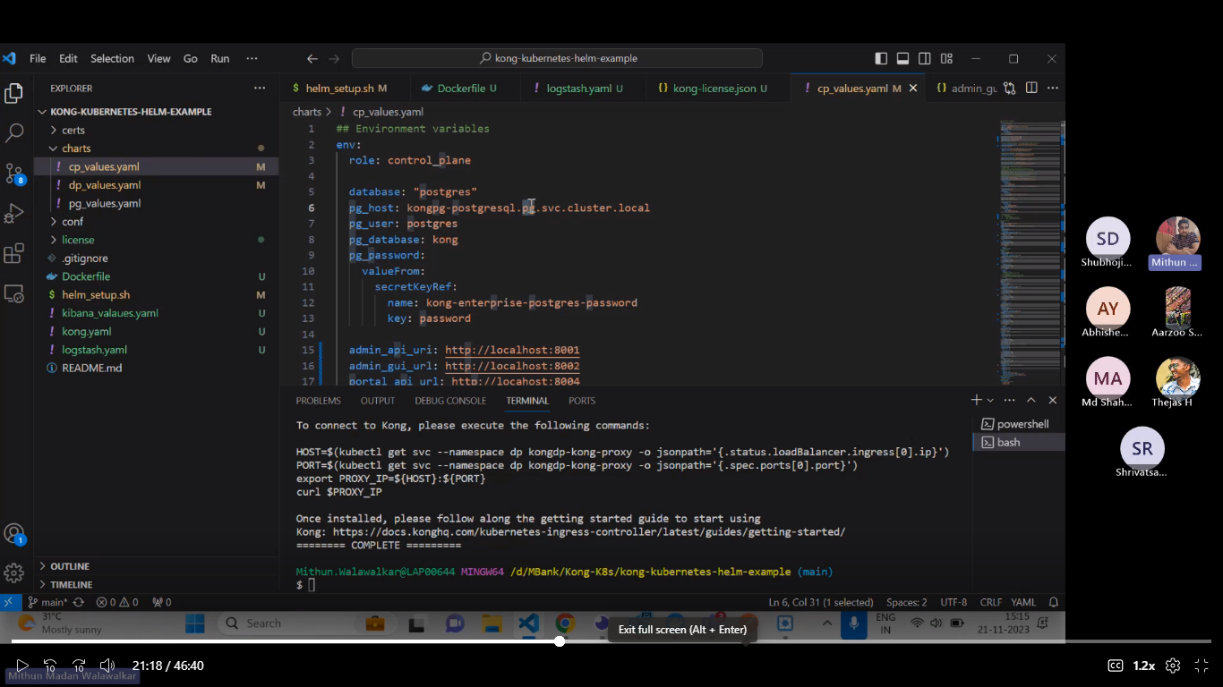
* Here role is the name that is control plane
* Then pg_host: kongpg-postgressql.pg.clsuter.local
* Here kongpg is the service name and pg is namespace and cluster and local.
* Here host will helps to connect the internally running postgres which iis in the cluster.
* 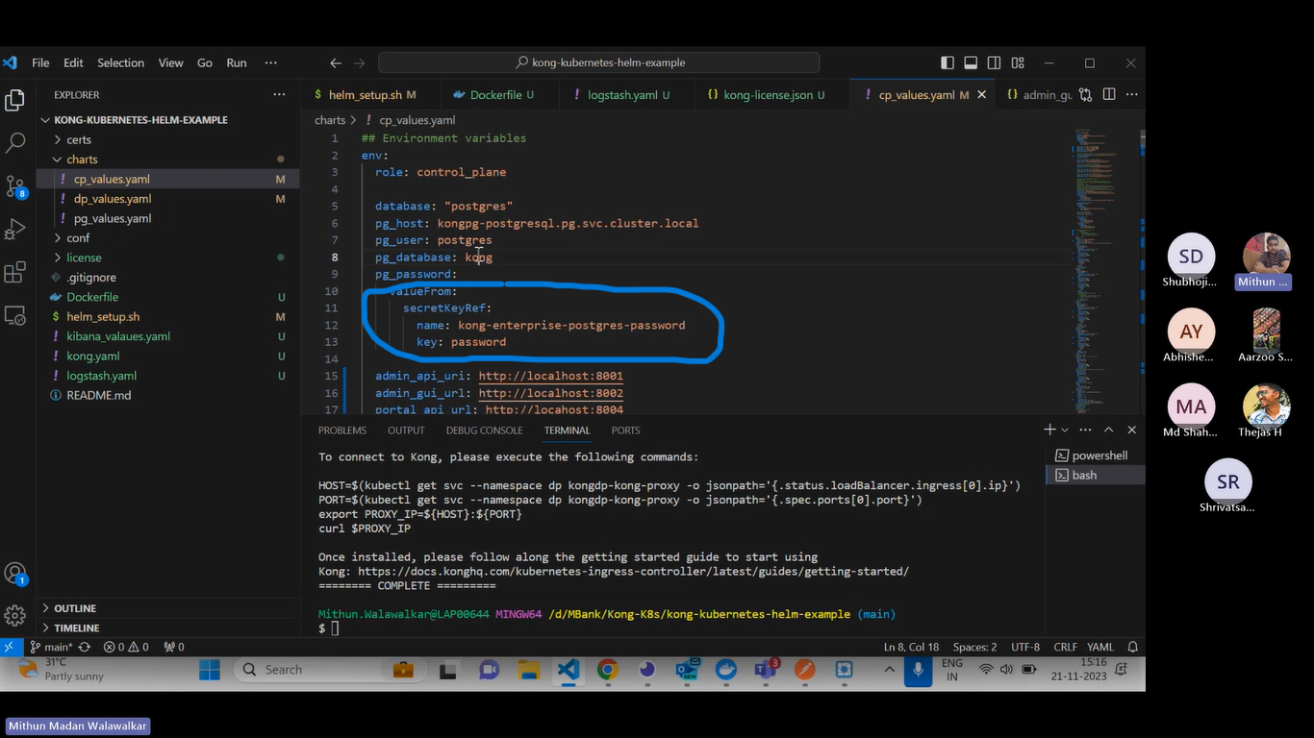
* Here pg password will be fetched from secrets in the cluster and from secrets it will go postrgesssql and from there it will check for password and here key name is kong-enterprise-postgres-password
* 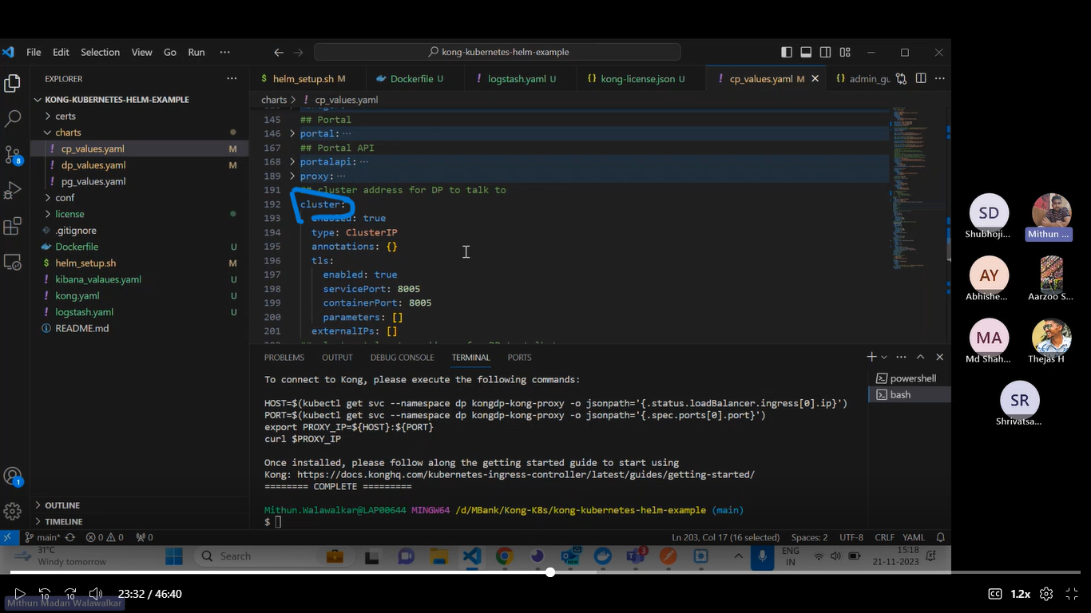
* There is something called as cluster and clustertelemetry this will come to picture when we deploy kong in hybrid mode
* So dataplane will connect to 8005 and it will listen to 8006 port
* 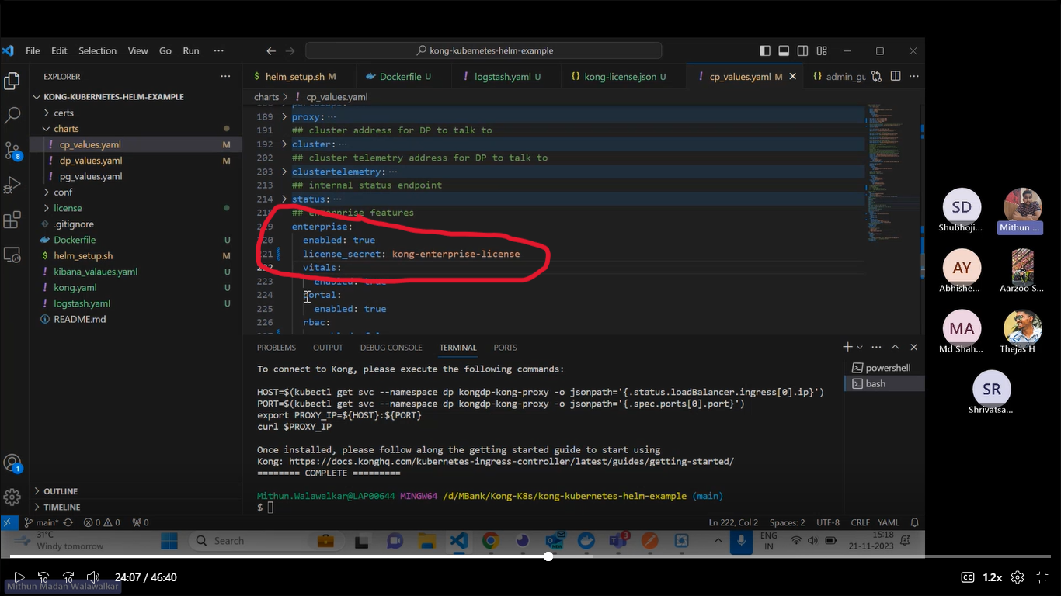
* For each thing you need to provide secret or liencce
* Here for enterprise we define the key names and then we provide keyname their we provide keyname it will fetch the lience from their.
* To connect dataplane and control we need to use cluster and clusetrtelemetry that we are running in controlplane and also we need to mention it in dataplane as well
* 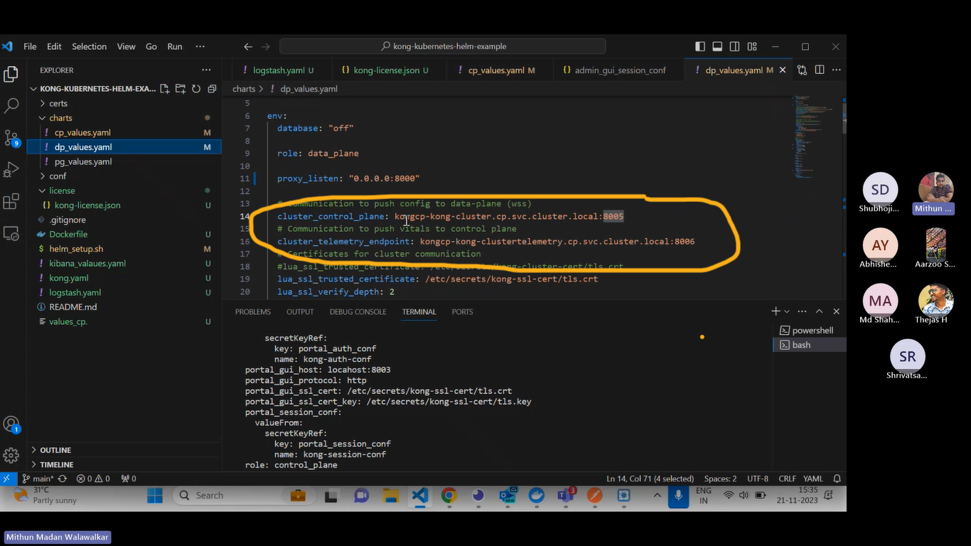
* The above thing is mentioned in datatplane where we are trying to connect to cluster inside the cluster.

**Kong Actual deployment in Mbank:**

* Azure container registry will be using for the storing the custom images which we will be doing for kong
* This is not official images from kong, we will take kong images as reference and then we will create our images that we arestoring in azure container registry.

**DataPlane is proxy and Kong manager is control Plane**

* 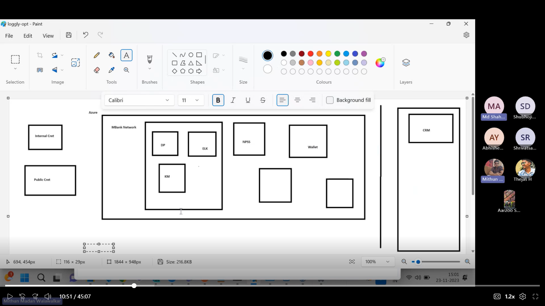
* CRM is the public vendor and it is hosted outside Mbank network.
* DP, ELK, KM is hosted inside MBank network and then CRM is s private network hosted outside the MBank Network.
* So in the left side we have creds and there is something called as internal creds which will be created for the mbank services to access
* Then we have public creds which is created to other external services to access.
* 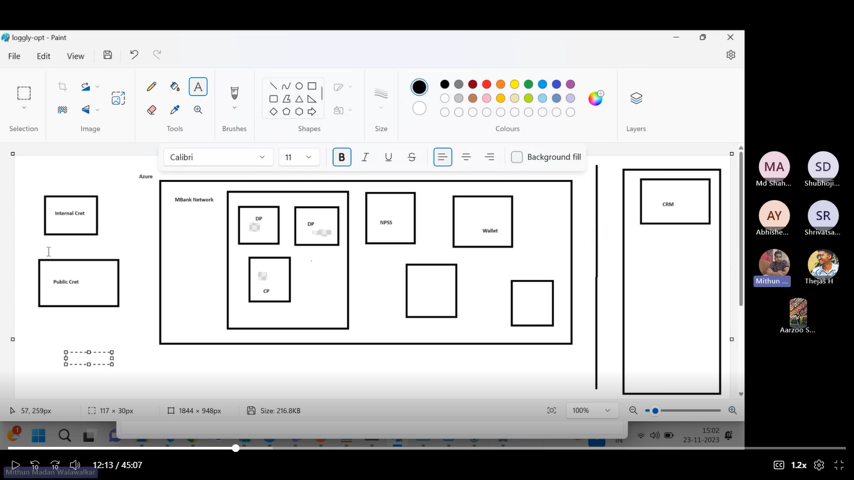
* There two data plane and one control plane deployed one data plane is for NPSS to access and then we another dataplane which helps crm to access.
* There are two certificates one is **hybrid creds** this is for cp and dp . this hybrid creds is shared by CP and DP. Then this hybrid creds will be used for internal communication
* Then we have CA certificates this will be used for public communication.
* This certificate mainly used by DPs for public communication.
* 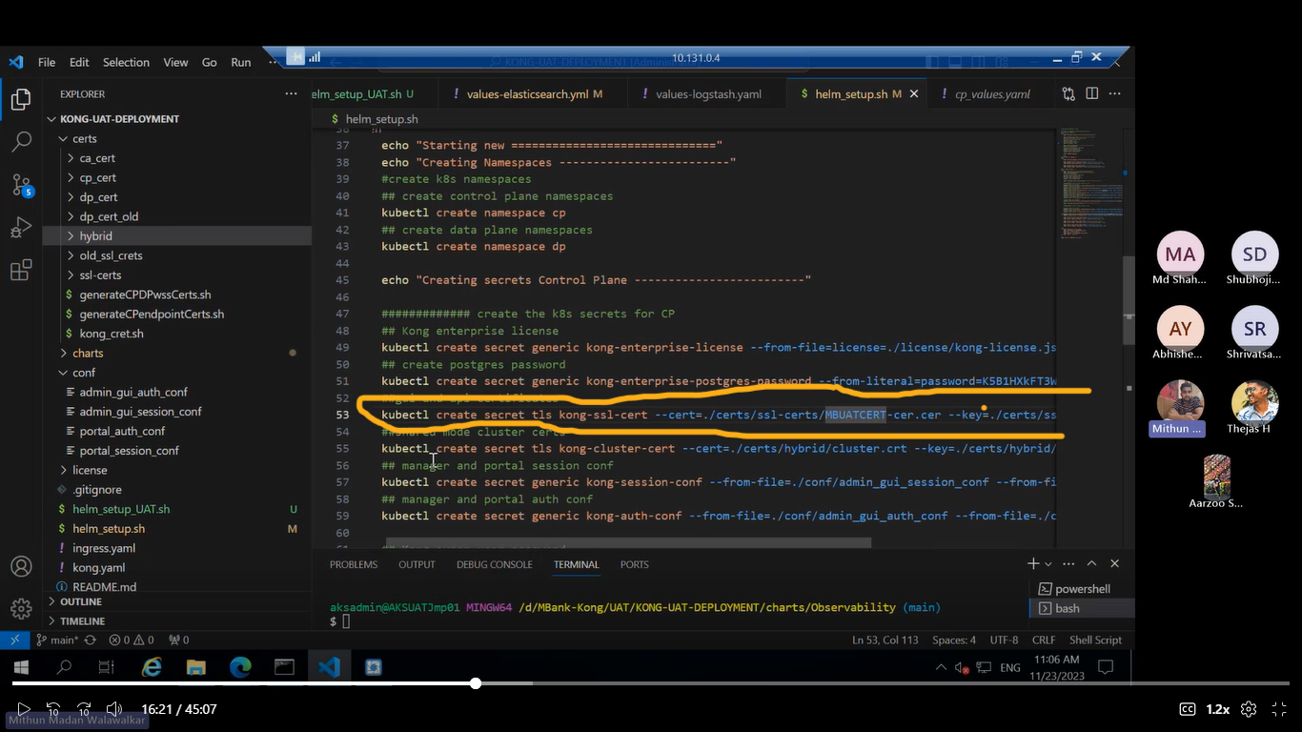
* For control plane communicates through dataplane if we want to acces any internal service which in mbank network hence we use internal certitiicate which is in ssl folder.
* 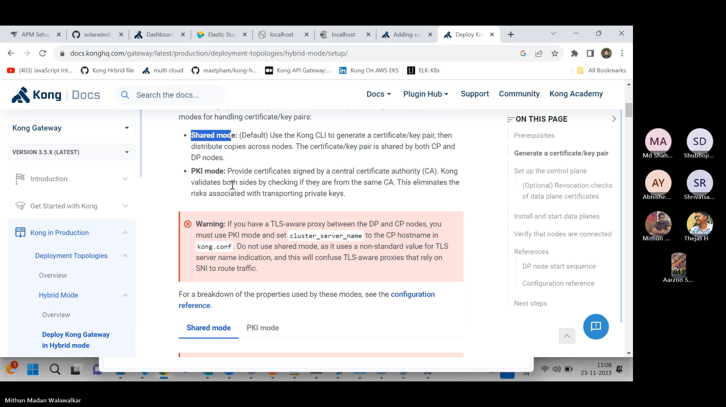
* There is something called as shared mode and PKI mode for shared mode certificate is shared between CP and DP.
* But for PKI mode we are deploying the certificates separately for each planes.
* 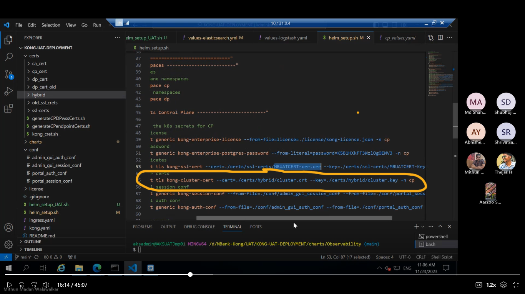
* Here for internal communication we use hybrid certificate this means certificate is shared between CP and DP.
* 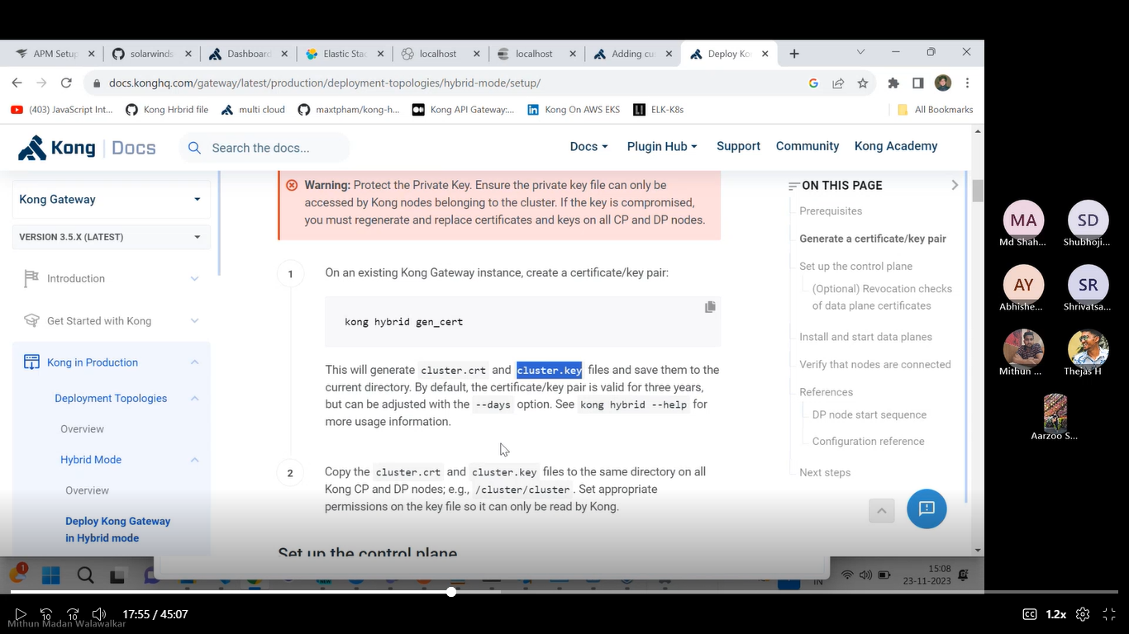
* If run kong hybrid gen_cert command it will generate the cluster.crt and cluster.key files.
* 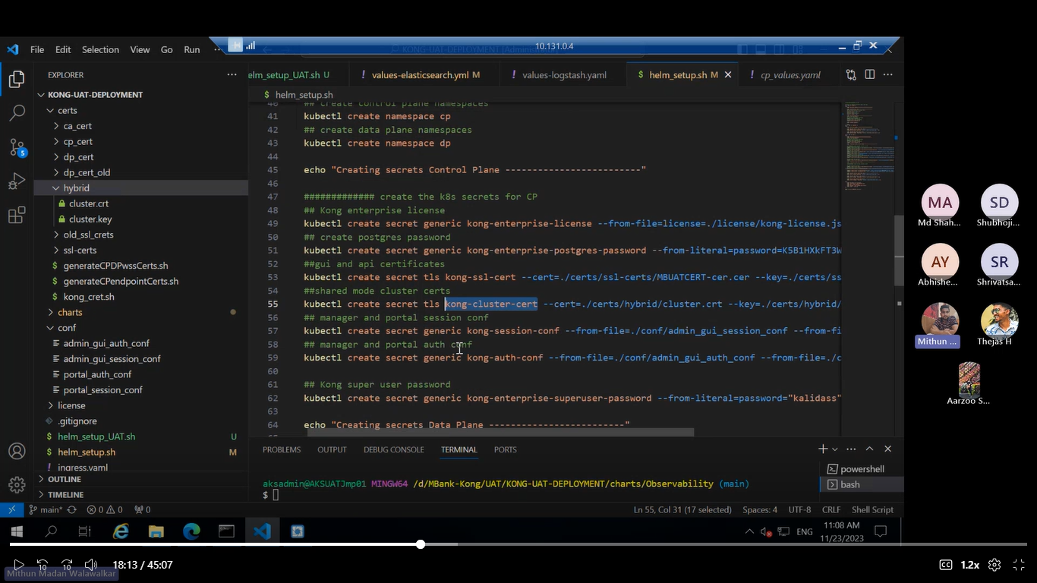
* Samething or certificate we need to add in dataplane also. Also same certificate we need to add in control plane.
* 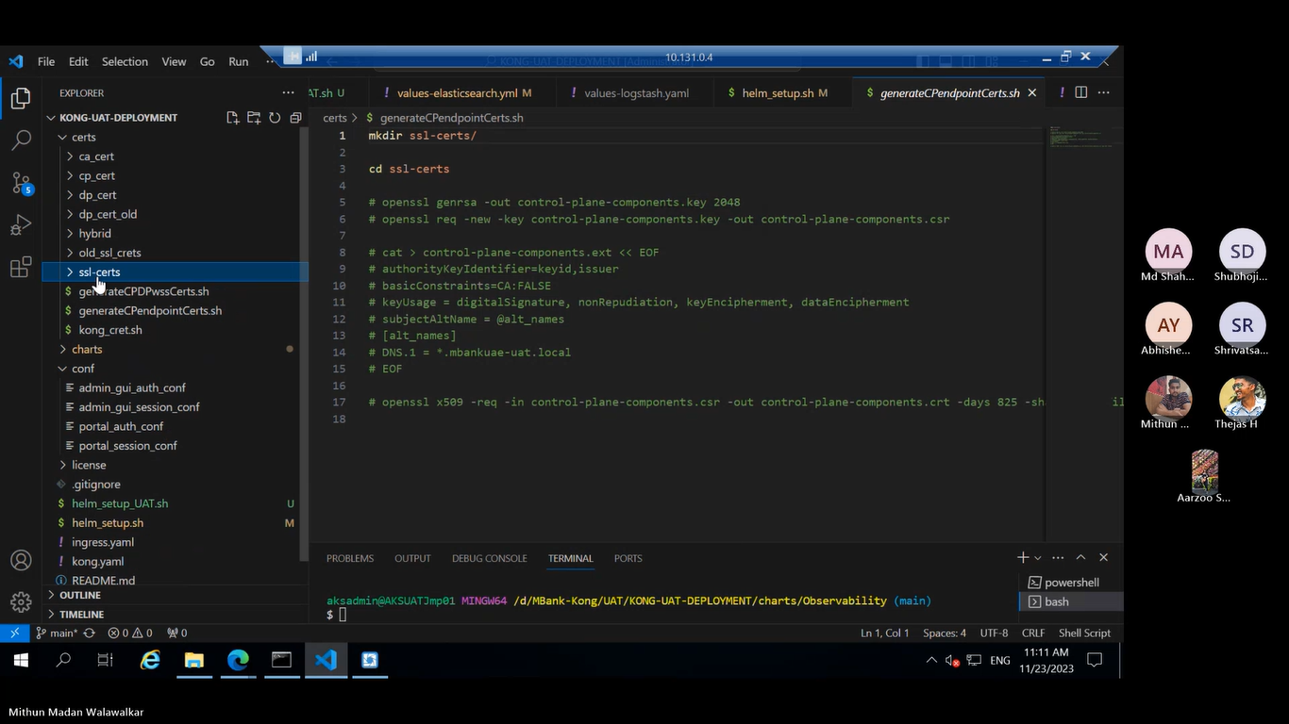
* This command helps to generate the certificates inside the ssl folders and so the certificate will be provided by infra twam itself.
* 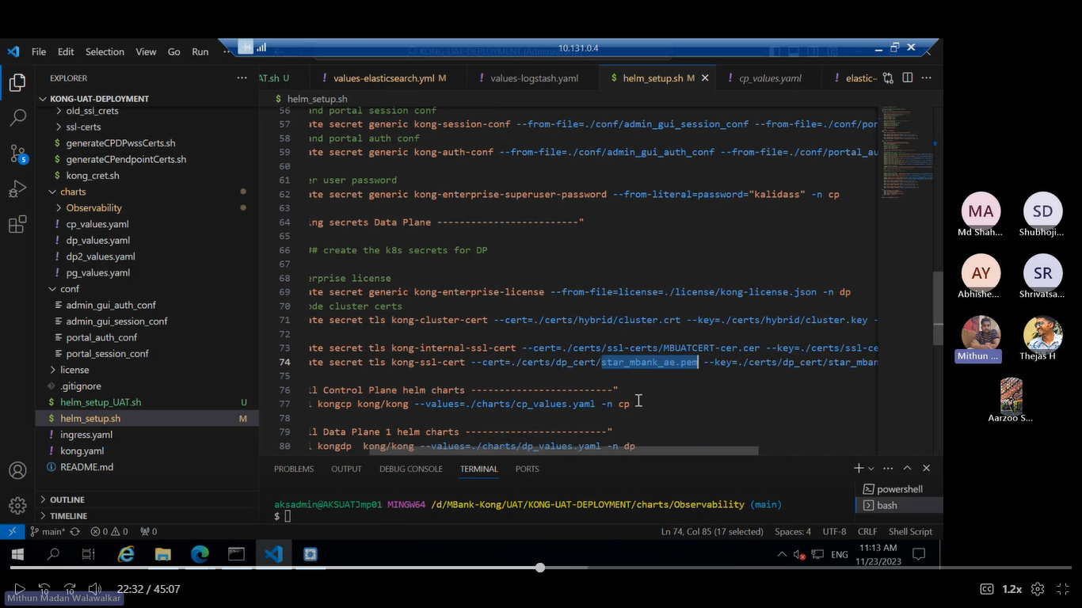
* Here in dataplanes we have two ssl certificates one is kong-internal-ssl-cert which is used for internal people to access and one more we have kong-ssl-cets which is used for kong external people to access.
* So for dataplne we are using two certificates.
* We have two dataplanes and one control plane.
* 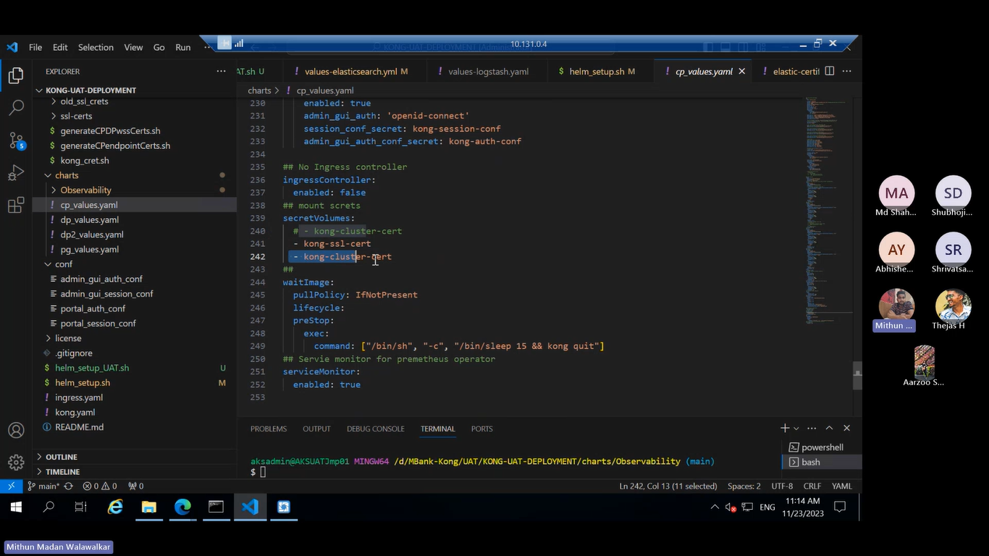
* We have to add the secrets to the cluster hence we are adding to the DP .
* 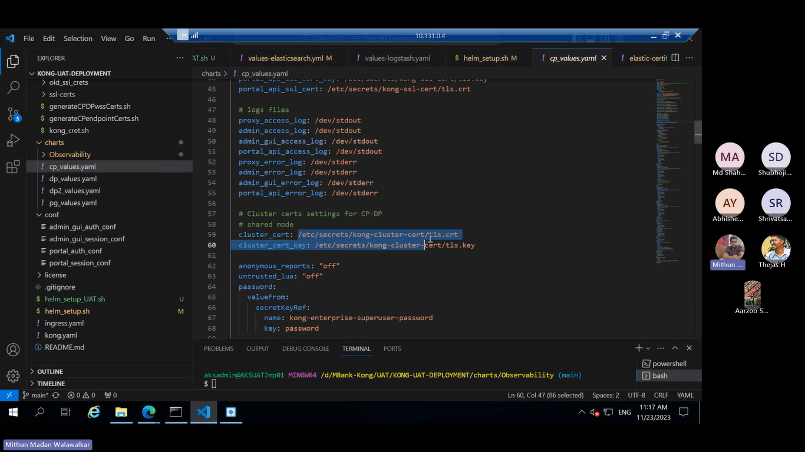
* For cp and dp communication we are using kong cluster certs not ssl certs.
* 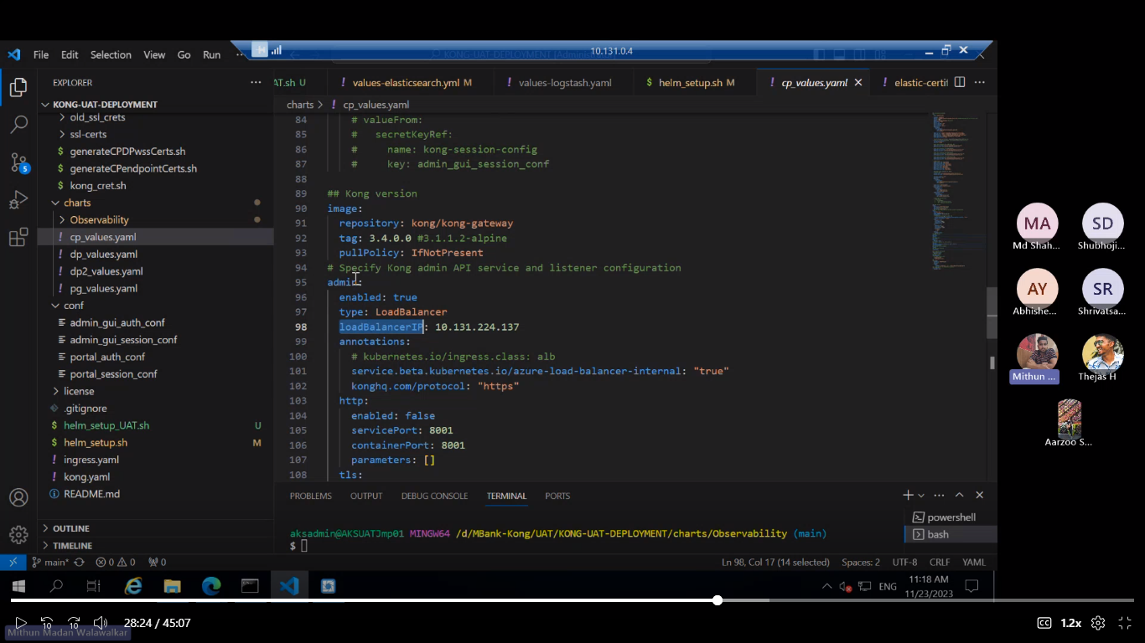
* In loadbalancer we have provided the IPs only this IP has to used by admin API, if your not providing the loadbalancer IP then it will take some random Ip and everytime it will keep on changing.
* If your not providing the LoadbalancerIp once you deploy and again yore deploy after doing some changes then it will change the IP again. So to keep the static IP we are providing the IP in the loadbalancer.
* 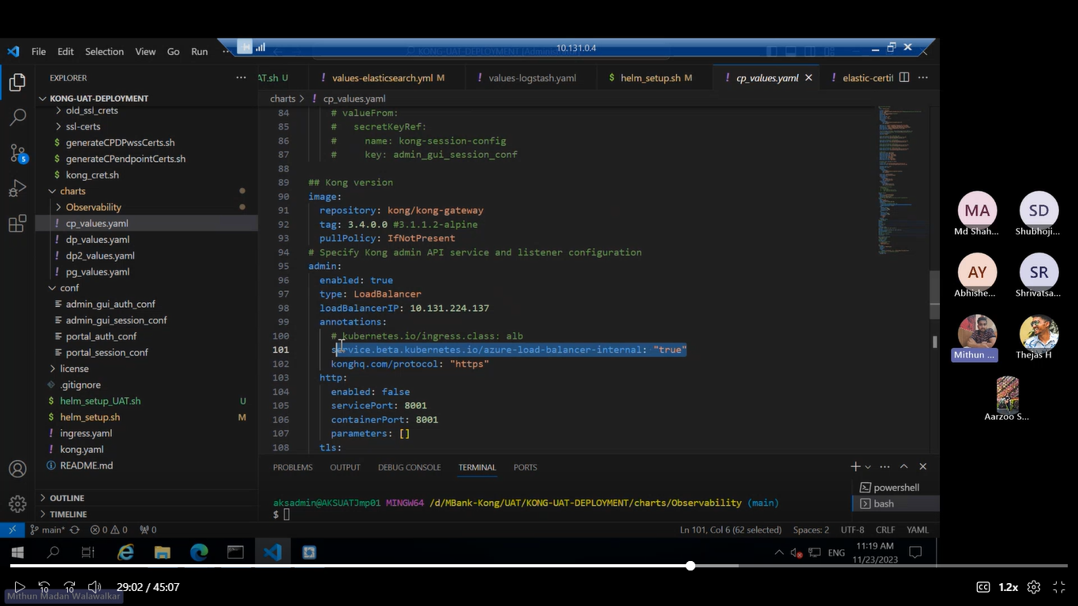
* IP you need to provide in the loadblancer which is under AKS subnet range and then you need to provide this annotations so that IP will be taken from ur internal range itself.
* 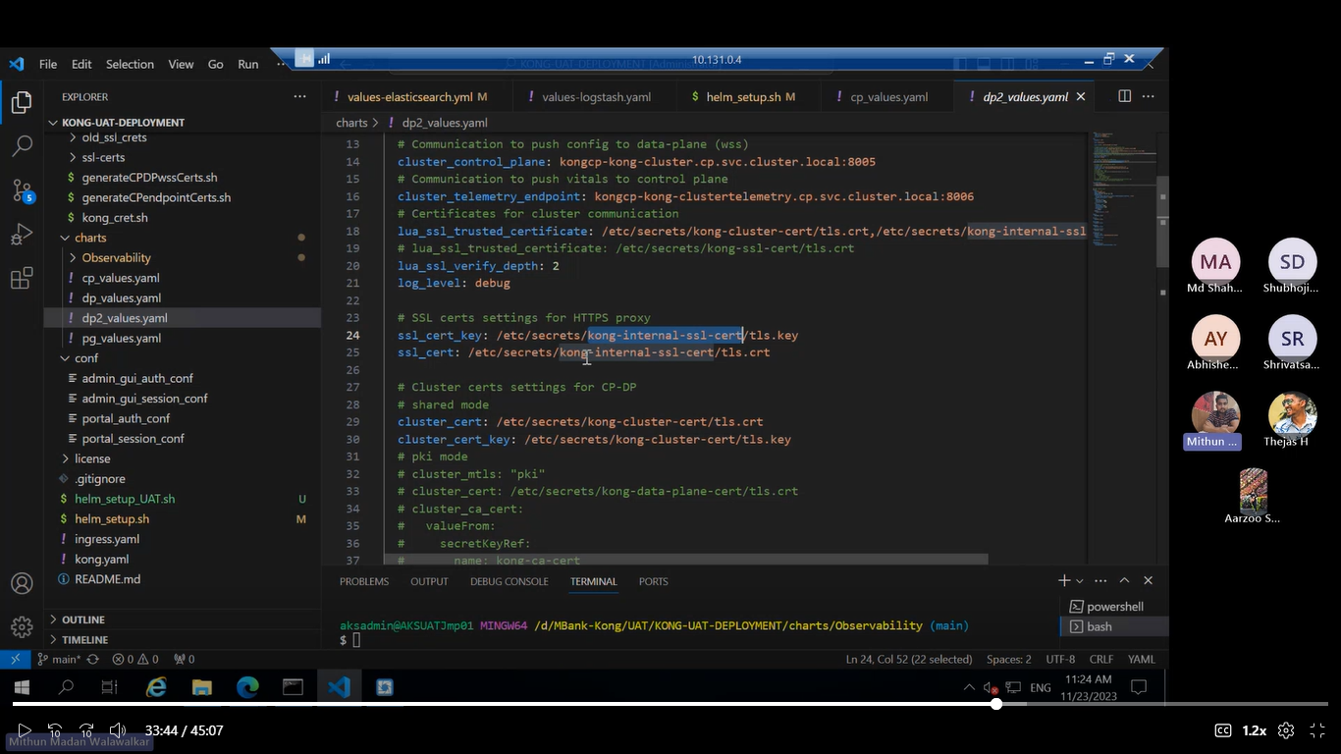
* This is kong internal ssl certs which is used for connecting users from mbank network hence we define internal certs in one dataplane and one more certs in another dataplane which for other services to access.
* We are configuring the service configuration in control plane.
* Then if we want to acces those services then we are accessing it through dataplane.
* If we have one control plane and two data planes then control plane will be common for both the data planes.